~ To install maven using specific java version(java-11)

MAVEN installation <https://www.tecmint.com/install-apache-maven-on-centos-7/>

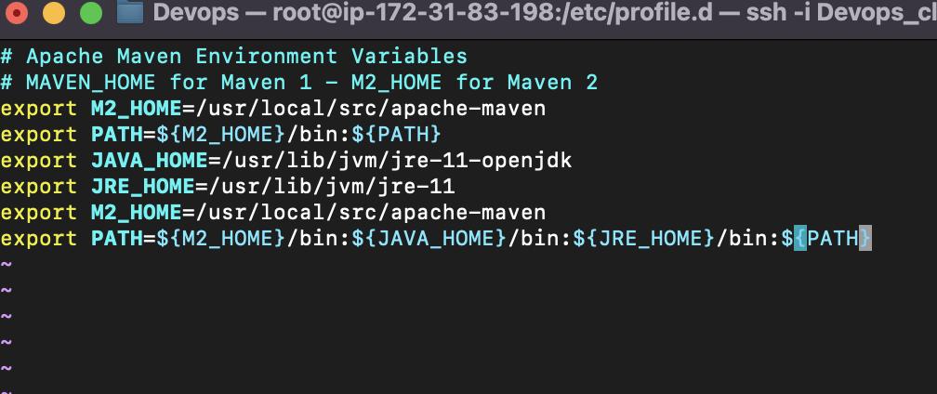

>vi /etc/profile.d/maven.sh

>source maven.sh

MAVEN ERROR: mvn is not found in Jenkins because Jenkins could not identify the path of maven so this is resolved by two methods

If **mvn** is working in your terminal but not in the Jenkins execute shell, there are a few things you can try to troubleshoot the issue:

1. Check the PATH environment variable: Jenkins may not have the correct PATH set up to find the **mvn** executable. To check the PATH, add the following line to your Jenkins execute shell script: **echo $PATH**. Then compare the output to the PATH in your terminal. If the PATH in Jenkins does not include the directory containing the **mvn** executable, you can add it to the PATH by adding the following line to your Jenkins execute shell script: **export PATH=$PATH:/path/to/mvn**.
2. Check the Maven installation directory: Make sure that Jenkins is using the correct Maven installation directory. To check this, add the following line to your Jenkins execute shell script: **echo $M2_HOME**. Then compare the output to the Maven installation directory in your terminal. If the Maven installation directory in Jenkins is not correct, you can set it by adding the following line to your Jenkins execute shell script: **export M2_HOME=/path/to/maven**.
3. Check the Java version: Make sure that Jenkins is using the same Java version as your terminal. To check this, add the following line to your Jenkins execute shell script: **java -version**. Then compare the output to the Java version in your terminal. If the Java version in Jenkins is not correct, you can set it by adding the following line to your Jenkins execute shell script: **export JAVA_HOME=/path/to/java**.
4. Check the Maven settings.xml: Make sure that the Maven settings.xml file is correctly configured in Jenkins. To check this, add the following line to your Jenkins execute shell script: **cat $HOME/.m2/settings.xml**. Then compare the output to the settings.xml file in your terminal. If the settings.xml file in Jenkins is not correct, you can copy the settings.xml file from your terminal to the Jenkins workspace directory and set the MAVEN_OPTS environment variable to point to the new location. For example: **export MAVEN_OPTS="-Duser.home=/path/to/jenkins/workspace"**

Once you have identified the issue, you can make the necessary changes to your Jenkins execute shell script or your Jenkins configuration to ensure that **mvn** works correctly.

METHOD 1: explicitly adding maven installed folder to execute shell in jenkins

METHOD 2: To add maven to Jenkins path

Followed this to change path

<https://stackoverflow.com/questions/23502306/modify-path-variable-in-jenkins-master>

Maven installed using this <https://devopscube.com/install-maven-guide/>

The above problem can also be resolved by adding path of maven in Jenkins environmental variables

1.first check for the current environmental variables of Jenkins by using echo $PATH in execute shell and compare it with echo $PATH inside the machine where maven is installed if different

Then

By doing this a new path is added to Jenkins

This way you can change the environmental variables of Jenkins

Change java version in amazon-linux

Adding Jdk to Jenkins specific version to jenkins

<https://www.youtube.com/watch?v=RtzPUbVq-Nw>

Defining the specific version of java to build in pipeline

